**Introduction to the Document Object Model (DOM)**

**Add HTML Tree Generator to extension**

<https://chrome.google.com/webstore/detail/html-tree-generator/dlbbmhhaadfnbbdnjalilhdakfmiffeg/related>

**DOM:** Dominating the DOM to add functionality to HTML elements.

When user open a website we are waiting and want the user to press button and then change layout. Same when there are many users. Solution of this problem is impossible but DOM solves this.

The Document Object Model (DOM) is **a programming API for HTML and XML documents**. It defines the logical structure of documents and the way a document is accessed and manipulated.

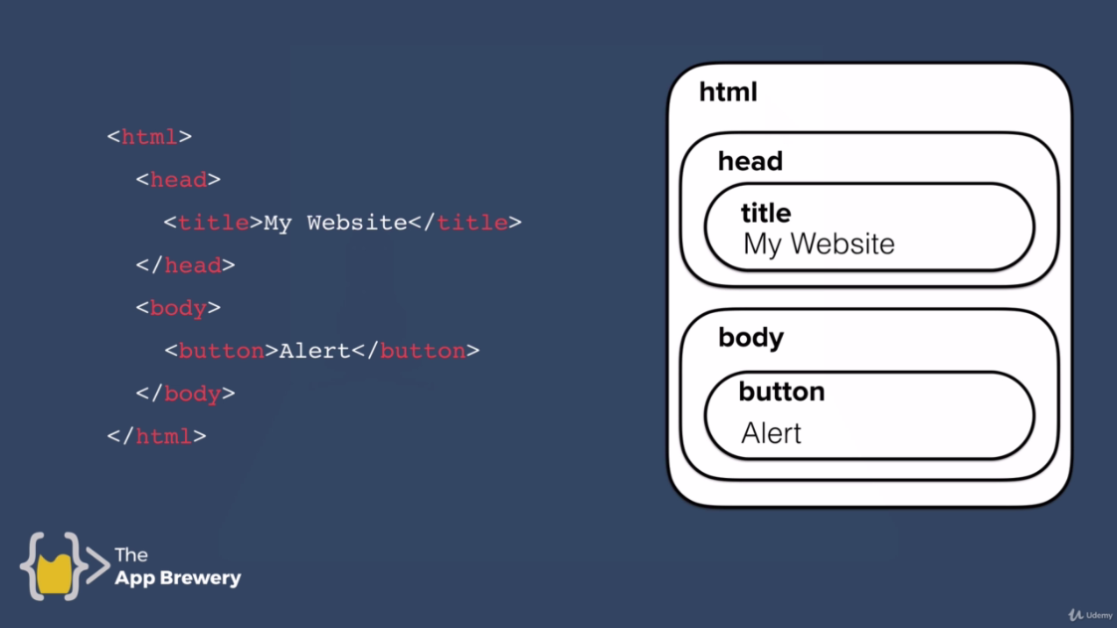

The task of converting html file to JS is done when loading the web-page.

**Tree Structure:**

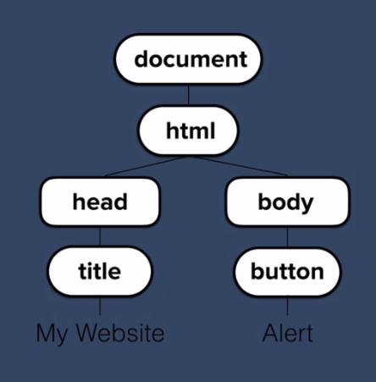

All the html elements are converted into object as shown by tree diagram.

**Structure of organization**

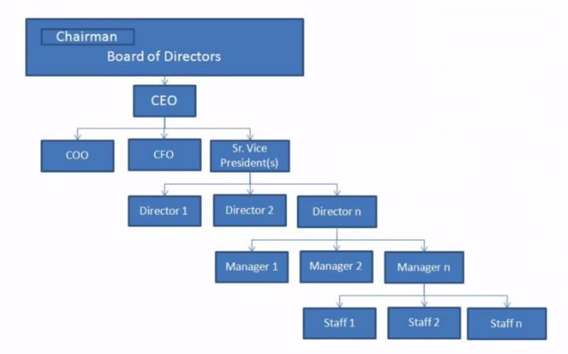

It is divided into bosses and supportners.

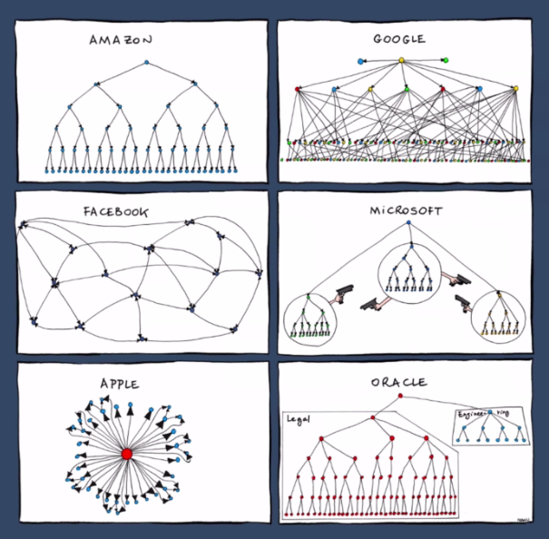

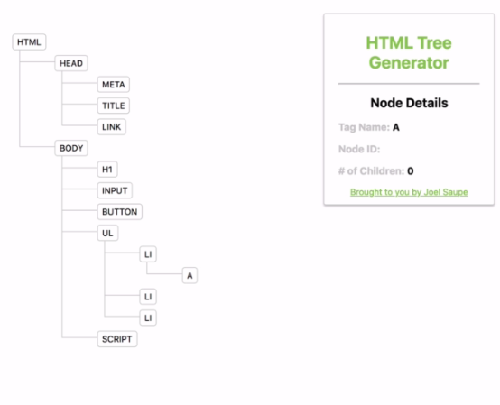

Above structure is of below code.

Object document has properties and methods.

Method associated with an object is **car.drive();**

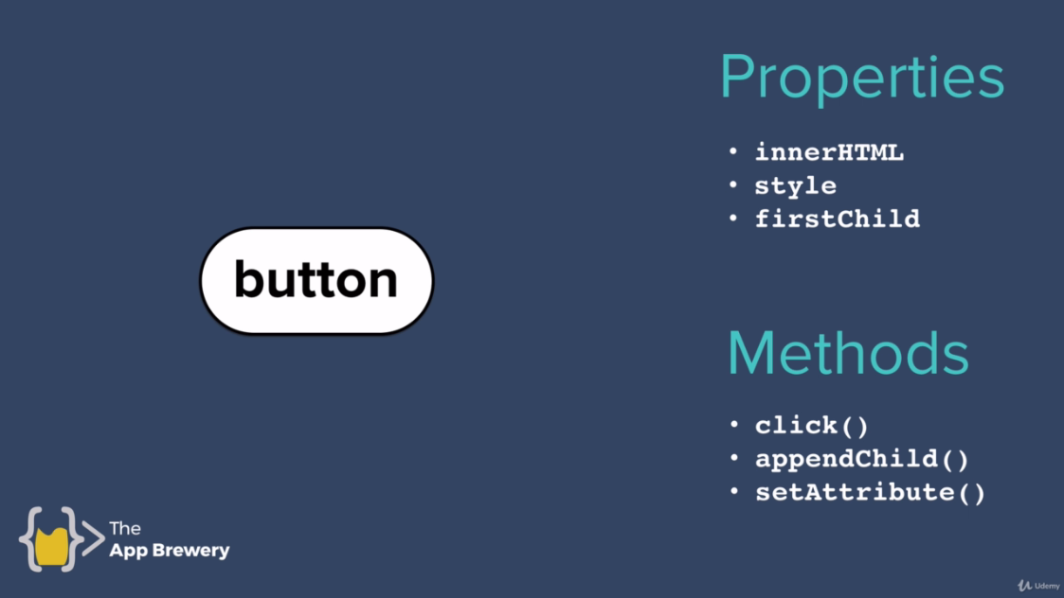

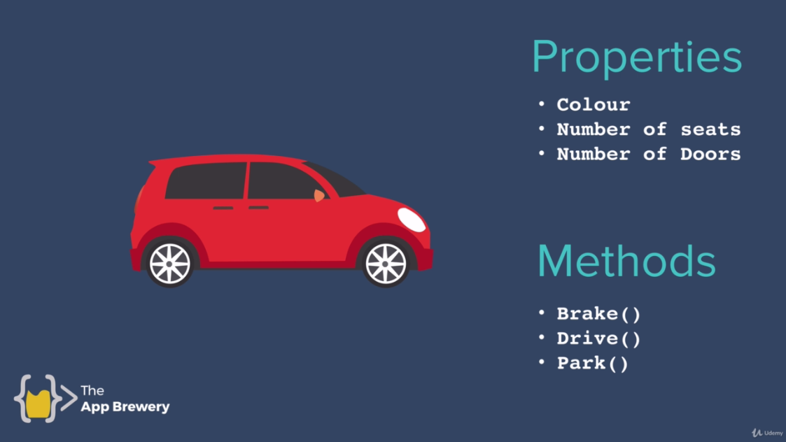

**Code:**

**Index3.html:**

<!DOCTYPE html>

<html lang="en" dir="ltr">

<head>

<meta charset="utf-8">

<title>My Website</title>

<link rel="stylesheet" href="css/styles3.css">

</head>

<body>

<h1>Hello</h1>

<input type="checkbox">

<button style=":active: color:red;" >Click Me</button>

<!-- Add list -->

<ul>

<li class="list">

<a href="http://www.google.com">Google</a>

</li>

<li class="list">Second</li>

<li class="list">Third</li>

</ul>

<script src="index3.js" charset="utf-8"></script>

</body>

</html>

**Styles3.css:**

h1{

//color: red;

}

**Index3.js:**

//document.querySelector("h1").innerHTML = "Good Bye!"; //Current h1 ia Hello but I'm change it with Good Bye

